Dual-Function-Prepositions
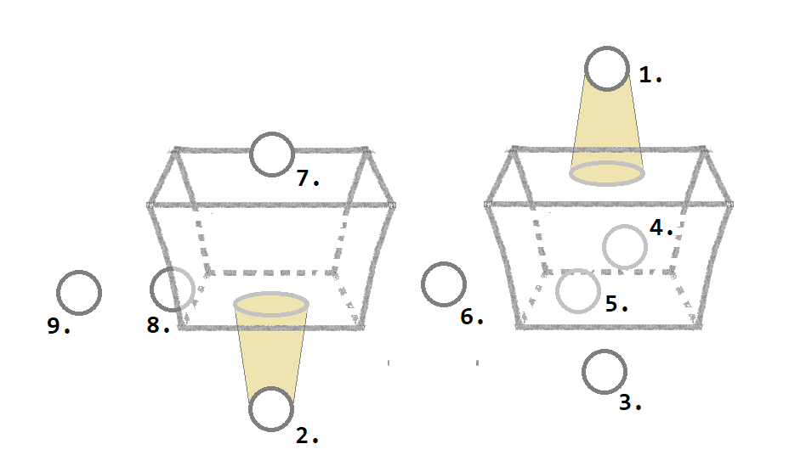
Wo? (Dativ) | Wohin? (Akkusativ) | Woher? (Dativ)
über / überm (m./n.)  unter / unterm (m./n.)  vor / vorm (m./n.)  hinter / hinterm (m./n.)  in /i m (m./n.)  zwischen  auf  an / am (m./n.)  neben  bei | über / übers (n.)  unter/unters (n.)  vor/vors (n.)  hinter/hinters (n.)  in/ins (n.)  zwischen  auf/aufs (n.)  an/ans (n.)  neben/ nebens (n.)  [zu/zum/zur] (m./n/f.)* | von / über ... weg  unter … hervor  vor … weg  hinter … hervor  aus … / aus … heraus  zwischen … hervor  von … / von … herunter  von ...  von ...  von / vom

..…………………………………………………………………………………………………………………………………………………………….
(m./n./f) merges with masculine, neutral and feminie definit articel "der", "das", "die"
in dem -> im etc.
..…………………………………………………………………………………………………………………………………………………………….
(m./n.) merges with masculine and neutral definit articel "der", "das"
in dem -> im etc.
..…………………………………………………………………………………………………………………………………………………………….
(n.) merges with neutral definit articel "das"
in das -> ins etc.

Note: For the questions „wo - where“ and „wohin - where to“ the prepositions for location and direction are mostly equal. For the question „woher - where from“ the prepositions are often a little bit different.

Contracted Form. The contracted form is mostly used in the normal speech. The non-contracted form sounds to Germans as if you want to describe a specific thing more detailed, similar to „the“ and „this“.
Example.
[A] Ich bin am See - I am at the lake.
[B] An welchem See bist du? - At which lake are you?
[A] Ich bin an dem See mit der Insel.

